Based upon the Alliance for a Healthier generation model wellness policy
Updated 9/2016 to Reflect the USDA Final Rule. Adopted January 11, 2017.
Updated January 2018 to reflect new committee members.
Updated December 2018 to reflect revised protocol and information re altering the nutrition program of individual students
Updated January 2020 to include language that clarifies review processes, physical activity, staff as role models, and to include an addendum regarding monitoring of goal achievement.
Updated December 2020 to include a statement that the District has adopted a Pandemic Plan and a Suicide Prevention Plan, and both are available on the DHS website.
Updated M 2022 per Triennial Assessment review and Site Council Comment

Table of Contents
Preamble 3
School Wellness Committee 4
Committee Role and Membership 4
Leadership 4
Wellness Policy Implementation, Monitoring, Accountability and Community Engagement 5
Implementation Plan 5
Recordkeeping 5
Annual Notification of Policy 5
Triennial Progress Assessments 6
Revisions and Updating the Policy 6
Community Involvement, Outreach and Communications 6
Nutrition 7
School Meals 7
Staff Qualifications and Professional Development 8
Water 8
Competitive Foods and Beverages 8
Celebrations and Rewards 8
Fundraising 9
Nutrition Promotion 9
Nutrition Education 9
Essential Healthy Eating Topics in Health Education 10
Altering the Nutrition program of individual students 11
Food and Beverage Marketing in Schools 11
Physical Activity 12
Physical Education 12
Essential Physical Activity Topics in Health Education 13
Classroom Physical Activity Breaks 14
Active Academics 14
Before and After School Activities 14
Active Transport 14
Other Activities that Promote Student Wellness 15
Community Partnerships 15
Community Health Promotion and Family Engagement 16
Staff Wellness and Health Promotion 16
Professional Learning 16
Non Discrimination Policy 16
Glossary: 18
Extended School Day 18
School Campus 18
School Day 18
Triennial 18
Appendices: 19
Non-Food Celebration Ideas and Healthy Snack & Beverage Ideas 19
Smart Snacks 21
Fundraisers and Smart Snacks: Foods Not Intended for Consumption at School 22
Addendum 24
Monitoring Implementation of Goals: 24

Dunsmuir Joint Union High School Wellness Policy
Note: This “Basic” district-level wellness policy template meets the minimum Federal standards for local school wellness policy implementation under the final rule of the Healthy, Hunger-Free Kids Act of 2010, the Alliance for a Healthier Generation Healthy Schools Program Bronze-level award criteria, and minimum best practice standards accepted in the education and public health fields. Where appropriate, the template includes optional policy language school districts can use to establish a stronger policy that meets the Healthy Schools Program Silver or Gold award levels. School districts should choose policy language that meets their current needs and also supports growth over time] If you are using this tool to compare your policy against, you should include the language in italics as the strongest examples for comparison.

Preamble
Dunsmuir Joint Unified School District (hereto referred to as the District) is committed to the optimal development of every student. The District believes that for students to have the opportunity to achieve personal, academic, developmental and social success, we need to create positive, safe and health-promoting learning environments at every level, in every setting, throughout the school year.
Research shows that two components, good nutrition and physical activity before, during and after the school day, are strongly correlated with positive student outcomes. For example, student participation in the U.S. Department of Agriculture’s (USDA) School Breakfast Program is associated with higher grades and standardized test scores, lower absenteeism and better performance on cognitive tasks.,,,,,, Conversely, less-than-adequate consumption of specific foods including fruits, vegetables and dairy products, is associated with lower grades among students.,, In addition, students who are physically active through active transport to and from school, recess, physical activity breaks, high-quality physical education and extracurricular activities – do better academically.,,,. Finally, there is evidence that adequate hydration is associated with better cognitive performance. ^{15,16,17}
This policy outlines the District’s approach to ensuring environments and opportunities for all students to practice healthy eating and physical activity behaviors throughout the school day while minimizing commercial distractions. Specifically, this policy establishes goals and procedures to ensure that:
- Students in the District have free access to healthy foods throughout the school day in accordance with Federal and State requirements and nutrition standards;
- Students receive quality nutrition education that helps them develop lifelong healthy eating behaviors;
- Students have opportunities to be physically active before, during and after school;
- Schools engage in nutrition and physical activity promotion and other activities that promote student wellness;
- School staff are encouraged and supported to practice healthy nutrition and physical activity behaviors in and out of school;
- The community is engaged in supporting the work of the District in creating continuity between school and other settings for students and staff to practice lifelong healthy habits; and
- The District establishes and maintains an infrastructure for management, oversight, implementation, communication about and monitoring of the policy and its established goals and objectives.
- The District provides Mental Health care through special events and speakers, as well as through contracts with medical specialists.
- Thus far, the District has not provided meals during the summer. There are other organizations that do provide .a free lunch to students during summer, and our students are apprised of where and how to take advantage of those programs.
- The Dunsmuir Joint Union High School District is essentially a single school district. There is occasionally a Community Day School, as necessary, but those students utilize the same cafeteria for breakfasts and lunches. This policy, therefore, applies to all students, staff and schools in the District. Specific measureable goals and outcomes are identified within each section below.

School Wellness Committee

Committee Role and Membership
The District will utilize the Site Council as the district wellness committee (hereto referred to as the DWC to establish goals for and oversee school health and safety policies and programs, including development, implementation and periodic review and update of this district-level wellness policy (heretofore referred as “wellness policy”). Composition of the Site Council fulfills many of the stakeholder requirements – Administration, teachers, students and parents, and meetings are open to the public. Agendas for the site council meetings are posted 72 hours ahead of the meetings.
The wellness plan review will be expanded to represent and include (to the extent possible), but not be limited to: caregivers; representatives of the school nutrition program (e.g., school nutrition director); physical education teachers; health education teachers; school health professionals (e.g., health education teachers, school health services staff [e.g., nurses, physicians, dentists, health educators, and other allied health personnel who provide school health services], and mental health and social services staff [e.g., school counselors, psychologists, social workers, or psychiatrists]; school board members; and the general public as the need arises. This will be done by individual invitation to the Site Council meetings where the Wellness Plan is reviewed or discussed. Public will also be welcomed to participate in those meetings at any time, as stated on the agenda, but only the committee members will be voting members.

Leadership
The Superintendent or designee(s) will place the wellness plan on the agenda for site council review, and facilitate development of and updates to the wellness policy, and will ensure each school’s compliance with the policy. The current designated official for oversight is Superintendent /Principal, Raymond Kellar. The Current Site Council composition can be obtained from the District office, as it changes annually. Note all members can be reached through the district office at 530-235-4835.

Wellness Policy Implementation, Monitoring, Accountability and Community Engagement

Implementation Plan
The District will develop and maintain a plan for implementation and monitoring to manage and coordinate the execution of this wellness policy. The plan delineates roles, responsibilities, actions and timelines specific to each school; and includes information about who will be responsible to make what change, by how much, where and when; as well as specific goals and objectives for nutrition standards for all foods and beverages available on the school campus, food and beverage marketing, nutrition promotion and education, physical activity, physical education and other school-based activities that promote student wellness. It is recommended that the school use the Healthy Schools Program online tools to complete a school-level assessment based on the Centers for Disease Control and Prevention’s School Health Index, create an action plan that fosters implementation and generate an annual progress report. This wellness policy and the progress reports can be found at: http://dunsmuirhigh.k12.ca.us.

Recordkeeping
The District will retain records to document compliance with the requirements of the wellness policy at District’s Administrative Offices Documentation maintained in this location will include but will not be limited to:
- The written wellness policy;
- Documentation demonstrating that the policy has been made available to the public;
- Documentation of efforts to review and update the Local Schools Wellness Policy; including an indication of who is involved in the update and methods the district uses to make stakeholders aware of their ability to participate on the DWC;
- Documentation to demonstrate compliance with the annual public notification requirements;
- The most recent assessment on the implementation of the local school wellness policy;
- Documentation demonstrating the most recent assessment on the implementation of the Local School Wellness Policy has been made available to the public.

Annual Notification of Policy
The District will actively inform families and the public each year of basic information about this policy, including its content, any updates to the policy and implementation status. The District will make this information available via the district website and/or district-wide communications. The District will provide as much information as possible about the school nutrition environment. This will include a summary of the District’s events or activities related to wellness policy implementation. Annually, the District will also publicize the name and contact information of the District officials leading and coordinating the committee, as well as information on how the public can get involved with the school Site Council as it reviews the wellness plan.

Triennial Progress Assessments
At least once every three years, the District will evaluate compliance with the wellness policy to assess the implementation of the policy. The assessment will include:
- the extent to which schools under the jurisdiction of the District are in compliance with the wellness policy;
- the extent to which the District’s wellness policy compares to the Alliance for a Healthier Generation’s model wellness policy; and
- a description of the progress made in attaining the goals of the District’s wellness policy.

Such an evaluation was performed in the 2019-2020 school year, and again in the 2021-22 school year.
The District will actively notify households/families of the availability of the triennial progress report by posting it on the School Website.

Revisions and Updating the Policy
The Site Council, acting as the DWC, will update or modify the wellness policy based on the results of the annual School Health Index and triennial assessments and/or as District priorities change; community needs change; wellness goals are met; new health science, information, and technology emerges; and new Federal or state guidance or standards are issued. The wellness policy will be assessed and updated as indicated at least every three years, following the triennial assessment.

Community Involvement, Outreach and Communications
The District is committed to being responsive to community input, which begins with awareness of the wellness policy. The District will actively communicate ways in which representatives of DWC and others can participate in the development, implementation and periodic review and update of the wellness policy through a variety of means. The District will also inform parents of the improvements that have been made to school meals and compliance with school meal standards, availability of child nutrition programs (and how to apply, if necessary), and a description of and compliance with Smart Snacks in School nutrition standards (See Appendix). The District will use electronic mechanisms, such as email or displaying notices on the district’s website, as well as non-electronic mechanisms, such as newsletters, presentations to parents, or sending information home to parents, to ensure that all families are actively notified of the content of, implementation of, and updates to the wellness policy, as well as how to get involved and support the policy. The District will ensure that communications are culturally and linguistically appropriate to the community, and accomplished through means similar to other ways that the district is communicating important school information with parents.
The District will actively notify the public about the content of or any updates to the wellness policy annually, at a minimum, via the Site Council Agenda and Minutes. The District will also use these mechanisms to inform the community about the availability of the annual and triennial reports.

Nutrition

School Meals
Our school district is committed to serving healthy meals to children, with plenty of fruits, vegetables, whole grains, and fat-free and low-fat milk; that are moderate in sodium, low in saturated fat, and have zero grams trans fat per serving (nutrition label or manufacturer’s specification); and to meeting the nutrition needs of school children within their calorie requirements. The school meal programs aim to improve the diet and health of school children, help mitigate childhood obesity, model healthy eating to support the development of lifelong healthy eating patterns and support healthy choices while accommodating cultural food preferences and special dietary needs.
All schools within the District participate in USDA child nutrition programs, including the Universal School Meals Program which includes breakfast and lunch at no cost to all students. The District also operates additional nutrition-related programs and activities including Second Chance Breakfast, the addition of a school garden and Farm to School Program. All schools within the District are committed to offering school meals to all students at no cost, that:
- Are accessible to all students;
- Are appealing and attractive to children;
- Are served in clean and pleasant settings;
- Meet or exceed current nutrition requirements established by local, state, and Federal statutes and regulations. (The District offers reimbursable school meals that meet USDA nutrition standards.)
- Promote healthy food and beverage choices using at least ten of the following Smarter Lunchroom techniques:
  - Whole fruit options are displayed in attractive bowls or baskets (instead of chaffing dishes or hotel pans).
  - Sliced or cut fruit is available daily.
  - Daily fruit options are displayed in a location in the line of sight and reach of students.
  - All available vegetable options have been given creative or descriptive names.
  - Daily vegetable options are bundled into all grab-and-go meals available to students.
  - All staff members, especially those serving, have been trained to politely prompt students to select and consume the daily vegetable options with their meal.
  - White milk is placed in front of other beverages in all coolers.
  - Alternative entrée options (e.g., salad bar, yogurt parfaits, etc.) are highlighted on posters or signs within all service and dining areas.
  - A reimbursable meal can be created in any service area available to students (e.g., salad bars, snack rooms, etc.).
  - Student surveys and taste testing opportunities are used to inform menu development, dining space decor and promotional ideas.
  - Student artwork is displayed in the service and/or dining areas.
  - Daily announcements are used to promote and market menu options.
- The District child nutrition program will accommodate students with special dietary needs.
- Students will be allowed at least 10 minutes to eat breakfast and at least 20 minutes to eat lunch, counting from the time they have received their meal and are seated (meets Healthy Schools Program Gold-level criteria).
- Students are served lunch at a reasonable and appropriate time of day.
- Participation in Federal child nutrition programs will be promoted among students and families to help ensure that families know what programs are available in their children’s school.

Staff Qualifications and Professional Development
All school nutrition program directors, managers and staff will meet or exceed hiring and annual continuing education/training requirements in the USDA professional standards for child nutrition professionals. These school nutrition personnel will refer to USDA’s Professional Standards for School Nutrition Standards website to search for training that meets their learning needs.

Water
To promote hydration, free, safe, unflavored drinking water will be available to all students throughout the school day* and throughout every school campus* (“school campus” and “school day” are defined in the glossary). The District will make drinking water available where school meals are served during mealtimes.
- Water cups/jugs will be available in the cafeteria if a drinking fountain is not present.
- All water sources and containers will be maintained on a regular basis to ensure good hygiene and health safety standards. Such sources and containers may include drinking fountains, water jugs, hydration stations, water jets and other methods for delivering drinking water.]
- Students will be allowed to bring and carry (approved) water bottles filled with only water with them throughout the day.

Competitive Foods and Beverages
The District is committed to ensuring that all foods and beverages available to students on the school campus* during the school day* support healthy eating. Currently there are no competitive foods served during the school day. If that changes, the foods and beverages sold and served outside of the school meal programs (e.g., “competitive” foods and beverages) will meet the USDA Smart Snacks in School nutrition standards, at a minimum. Smart Snacks aim to improve student health and well-being, increase consumption of healthful foods during the school day and create an environment that reinforces the development of healthy eating habits. A summary of the standards and information, as well as a Guide to Smart Snacks in Schools are available at: http://www.fns.usda.gov/healthierschoolday/tools-schools-smart-snacks. The Alliance for a Healthier Generation provides a set of tools to assist with implementation of Smart Snacks available at www.foodplanner.healthiergeneration.org.
To support healthy food choices and improve student health and well-being, all foods and beverages outside the reimbursable school meal programs that are sold to students on the school campus during the school day will meet or exceed the USDA Smart Snacks nutrition standards (See Appendix) These standards will apply in all locations and through all services where foods and beverages are sold, which may include, but are not limited to, à la carte options in cafeterias, vending machines, school stores and snack or food carts.

Celebrations and Rewards
All foods offered on the school campus are encouraged to meet or exceed the USDA Smart Snacks in School nutrition standards including through:
- Celebrations and parties. See Appendix for a list of healthy party ideas, including non-food celebration ideas. Healthy party ideas are available from the Alliance for a Healthier Generation and from the USDA.
- Classroom snacks brought by parents. Follow the link for a list of foods and beverages that meet Smart Snacks nutrition standards.
- Rewards and incentives. See Appendix for a list of alternative ways to reward children. Foods and beverages will not be used as a reward, or withheld as punishment for any reason, such as for performance or behavior.
[Meets Healthy Schools Program Silver-level criteria]

Fundraising
Foods and beverages that meet or exceed the USDA Smart Snacks in Schools nutrition standards may be sold through fundraisers on the school campus* during the school day*. See Appendix for a list of healthy fundraising ideas [examples from the Alliance for a Healthier Generation and the USDA].
- Schools encourage use of only non-food fundraisers, and encourage those promoting physical activity (such as walk-a-thons, Jump Rope for Heart, fun runs, etc.).
- Fundraising during and outside school hours are encouraged to sell only non-food items or foods and beverages that meet or exceed the Smart Snacks nutrition standards. These fundraisers may include but are not limited to, donation nights at restaurants, cookie dough, candy and pizza sales, market days, etc. (Meets Healthy Schools Program Gold-level criteria)]

Nutrition Promotion
Nutrition promotion and education positively influence lifelong eating behaviors by using evidence-based techniques and nutrition messages, and by creating food environments that encourage healthy nutrition choices and encourage participation in school meal programs. Students and staff will receive consistent nutrition messages throughout schools, classrooms, gymnasiums, and cafeterias. Nutrition promotion also includes marketing and advertising nutritious foods and beverages to students and is most effective when implemented consistently through a comprehensive and multi-channel approach by school staff, teachers, parents, students and the community.
The District will promote healthy food and beverage choices for all students throughout the school campus, as well as encourage participation in school meal programs. This promotion will occur through at least:
- Implementing at least ten or more evidence-based healthy food promotion techniques through the school meal programs using Smarter Lunchroom techniques; and
- Ensuring 100% of foods and beverages promoted to students meet the USDA Smart Snacks in School nutrition standards. Additional promotion techniques that the District and individual schools may use are available at http://www.foodplanner.healthiergeneration.org/.

Nutrition Education
The District will teach, model, encourage and support healthy eating by all students. Schools will provide nutrition education and engage in nutrition promotion that:
- Is designed to provide students with the knowledge and skills necessary to promote and protect their health;
- Is part of not only health education classes, but also integrated into other classroom instruction through subjects such as math, science, language arts, social sciences and elective subjects;
- Includes enjoyable, developmentally-appropriate, culturally-relevant and participatory activities, such as cooking demonstrations or lessons, promotions, taste-testing, farm visits and school gardens;
- Promotes fruits, vegetables, whole-grain products, low-fat and fat-free dairy products and healthy food preparation methods;
- Emphasizes caloric balance between food intake and energy expenditure (promotes physical activity/exercise);
- Links with school meal programs, cafeteria nutrition promotion activities, school gardens, Farm to School programs, other school foods and nutrition-related community services;
- Teaches media literacy with an emphasis on food and beverage marketing; and
- Includes nutrition education training for teachers and other staff.

Essential Healthy Eating Topics in Health Education
The District will include in the curriculum for Success 101 (College & Career Readiness/Health/ or PE, Food Services, Culinary Arts, and Consumer Math a minimum of 12 of the following essential topics on healthy eating:
- Relationship between healthy eating and personal health and disease prevention
- Food guidance from MyPlate
- Reading and using FDA's nutrition fact labels
- Eating a variety of foods every day
- Balancing food intake and physical activity
- Eating more fruits, vegetables and whole grain products
- Choosing foods that are low in fat, saturated fat, and cholesterol and do not contain trans fat
- Choosing foods and beverages with little added sugars
- Eating more calcium-rich foods
- Preparing healthy meals and snacks
- Risks of unhealthy weight control practices
- Accepting body size differences
- Food safety
- Importance of water consumption
- Importance of eating breakfast
- Making healthy choices when eating at restaurants
- Eating disorders
- The Dietary Guidelines for Americans
- Reducing sodium intake
- Social influences on healthy eating, including media, family, peers and culture
- How to find valid information or services related to nutrition and dietary behavior
- How to develop a plan and track progress toward achieving a personal goal to eat healthfully
- Resisting peer pressure related to unhealthy dietary behavior
- Influencing, supporting, or advocating for others’ healthy dietary behavior

Altering the Nutrition program of individual students
There are times when for special reasons, medical, religious or other, the standard menu prepared by the school does not suffice. There is a way parents can petition for something different. When students request a special meal there is a form that SCOE has that helps the nutrition person and provides documentation of the condition/illness/need. See the Food Services Director for the correct form.

Food and Beverage Marketing in Schools
The District is committed to providing a school environment that ensures opportunities for all students to practice healthy eating and physical activity behaviors throughout the school day while minimizing commercial distractions. The District strives to teach students how to make informed choices about nutrition, health and physical activity. These efforts will be weakened if students are subjected to advertising on District property that contains messages inconsistent with the health information the District is imparting through nutrition education and health promotion efforts. It is the intent of the District to protect and promote student’s health by permitting advertising and marketing for only those foods and beverages that are permitted to be sold on the school campus, consistent with the District’s wellness policy.

Any foods and beverages marketed or promoted to students on the school campus* during the school day* will meet or exceed the USDA Smart Snacks in School nutrition standards.

Food and beverage marketing is defined as advertising and other promotions in schools. Food and beverage marketing often includes an oral, written, or graphic statements made for the purpose of promoting the sale of a food or beverage product made by the producer, manufacturer, seller or any other entity with a commercial interest in the product. This term includes, but is not limited to the following:

- Brand names, trademarks, logos or tags, except when placed on a physically present food or beverage product or its container.
- Displays, such as on vending machine exteriors
- Corporate brand, logo, name or trademark on school equipment, such as marquees, message boards, scoreboards or backboards (Note: immediate replacement of these items are not required; however, districts will replace or update scoreboards or other durable equipment when existing contracts are up for renewal or to the extent that is in financially possible over time so that items are in compliance with the marketing policy.)
- Corporate brand, logo, name or trademark on cups used for beverage dispensing, menu boards, coolers, trash cans and other food service equipment; as well as on posters, book covers, pupil assignment books or school supplies displayed, distributed, offered or sold by the District.
- Advertisements in school publications or school mailings.
- Free product samples, taste tests or coupons of a product, or free samples displaying advertising of a product.

As the District Administration reviews existing contracts and considers new contracts, equipment and product purchasing (and replacement) decisions should reflect the applicable marketing guidelines established by the District wellness policy.

Physical Activity
Children and adolescents should participate in at least 60 minutes of physical activity every day. A substantial percentage of students’ physical activity can be provided through a comprehensive school physical activity program (CSPAP). A CSPAP reflects strong coordination and synergy across all of the components: quality physical education as the foundation; physical activity before, during and after school; staff involvement and family and community engagement. The District is committed to providing these opportunities. Schools will ensure that these varied physical activity opportunities are in addition to, and not as a substitute for, physical education (addressed in “Physical Education” subsection). The District will be encouraged to participate in Let’s Move! Active Schools (www.letsmoveschools.org) in order to successfully address all CSPAP areas.
Physical activity during the school day (including but not limited to, classroom physical activity breaks or physical education) will not be withheld as punishment for any reason. The district will counsel teachers and other school staff with a list of ideas for alternative ways to discipline students.
To the extent practicable, the District will ensure that its grounds and facilities are safe and that equipment is available to students to be active. The District will conduct necessary inspections and repairs. The District will consider having staff cover physical activities before and after class time, and during lunch. As an example, Pickle Ball was available during lunch break, and use of the weight room equipment was available after school. The School also organizes a “Helping Hands” community outreach program where students work on yards and homes or establishments in the neighborhood. This generates about six – ten hours per week for about 30% of the student population.
The District encourages all students to participate in sports and extra-curricular activities. The district strives to have at least two sports teams per season, as well as other clubs such as robotics and forestry to promote physical movement.

Physical Education
The District will provide students with physical education, using an age-appropriate, sequential physical education curriculum consistent with national and state standards for physical education. The physical education curriculum will promote the benefits of a physically active lifestyle and will help students develop skills to engage in lifelong healthy habits, as well as incorporate essential health education concepts (discussed in the “Essential Physical Activity Topics in Health Education” subsection). The curriculum will support the essential components of physical education.
All students will be provided equal opportunity to participate in physical education classes. The District will make appropriate accommodations to allow for equitable participation for all students and will adapt physical education classes and equipment as necessary.
All students are required to take the equivalent of one academic year of physical education, plus the equivalent of one year of health, positive prevention, first aid and nutrition.
The District physical education program will promote student physical fitness through individualized fitness and activity assessments (via the Presidential Youth Fitness Program or other appropriate assessment tool) and will use criterion-based reporting for each student.
[Additional policy language includes:
- Students will be moderately to vigorously active for at least 50% of class time during most or all physical education class sessions (meets Healthy Schools Program Silver-level criteria).
- All physical education teachers in [District] will be required to participate in at least a once a year professional development in education (meets Healthy Schools Program Silver-level criteria).
- All physical education classes in [District] are taught by licensed teachers who are certified or endorsed to teach physical education (meets Healthy Schools Program Gold-level criteria).
- Waivers, exemptions, or substitutions for physical education classes are not granted.

Essential Physical Activity Topics in Health Education
The District will require high school students to take and pass at least one health education course. The District will include in the health education curriculum a minimum of 12 the following essential topics on physical activity:
- The physical, psychological, or social benefits of physical activity
- How physical activity can contribute to a healthy weight
- How physical activity can contribute to the academic learning process
- How an inactive lifestyle contributes to chronic disease
- Health-related fitness, that is, cardiovascular endurance, muscular endurance, muscular strength, flexibility, and body composition
- Differences between physical activity, exercise and fitness
- Phases of an exercise session, that is, warm up, workout and cool down
- Overcoming barriers to physical activity
- Decreasing sedentary activities, such as TV watching
- Opportunities for physical activity in the community
- Preventing injury during physical activity
- Weather-related safety, for example, avoiding heat stroke, hypothermia and sunburn while being physically active
- How much physical activity is enough, that is, determining frequency, intensity, time and type of physical activity
- Developing an individualized physical activity and fitness plan
- Monitoring progress toward reaching goals in an individualized physical activity plan
- Dangers of using performance-enhancing drugs, such as steroids
- Social influences on physical activity, including media, family, peers and culture
- How to find valid information or services related to physical activity and fitness
- How to influence, support, or advocate for others to engage in physical activity
- How to resist peer pressure that discourages physical activity.

Classroom Physical Activity Breaks
The District recognizes that students are more attentive and ready to learn if provided with periodic breaks when they can be physically active or stretch. Thus, students will be offered periodic opportunities to be active or to stretch throughout the day on all or most days during a typical school week. The District recommends teachers provide short (3-5-minute) physical activity breaks to students during and between classroom time at least three days per week. These physical activity breaks will complement, not substitute for, physical education class, and class transition periods.
The District will provide resources and links to resources, tools, and technology with ideas for classroom physical activity breaks. Resources and ideas are available through USDA and the Alliance for a Healthier Generation.

Active Academics
Teachers will incorporate movement and kinesthetic learning approaches into “core” subject instruction when possible (e.g., science, math, language arts, social studies and others) and do their part to limit sedentary behavior during the school day.
The District will support classroom teachers incorporating physical activity and employing kinesthetic learning approaches into core subjects by providing annual professional development opportunities and resources, including information on leading activities, activity options, as well as making available background material on the connections between learning and movement.
Teachers will serve as role models by being physically active alongside the students whenever feasible.

Before and After School Activities
The District offers opportunities for students to participate in physical activity either before and/or after the school day (or both) through a variety of methods. The District will encourage students to be physically active before and after school by:
- Providing several sports and activities;
- Scheduling practice for at least 1 hour/day after school; and
- Providing healthy snacks and or meals for long distance competitions.

Active Transport
The District will support active transport to and from school, such as walking or biking. The District will encourage this behavior by engaging in six or more of the activities below; including but not limited to:
- Create and distribute maps of school environment (e.g., sidewalks, crosswalks, roads, pathways, bike racks, etc.)

Other Activities that Promote Student Wellness
The District will integrate wellness activities across the entire school setting, not just in the cafeteria, other food and beverage venues and physical activity facilities. The District will coordinate and integrate other initiatives related to physical activity, physical education, nutrition and other wellness components so all efforts are complementary, not duplicative, and work towards the same set of goals and objectives promoting student well-being, optimal development and strong educational outcomes.
Schools in the District are encouraged to coordinate content across curricular areas that promote student health, such as teaching nutrition concepts in mathematics, with consultation provided by either the school or the District’s curriculum experts.
All efforts related to obtaining federal, state or association recognition for efforts, or grants/funding opportunities for healthy school environments will be coordinated with and complementary of the wellness policy, including but not limited to ensuring the involvement of the Site Council.
The District recognizes that mental health is a key component to overall wellness and to student success. As such, it maintains a contract for services from a school nurse who has access to a school psychologist, and to a behavior therapist who visits the school daily. Special events are planned that are designed to promote mental health, including keynote speakers and occasional activities. In the 2022-23 school year, the District is contracting with the County Office of Education for assistance from them with activities and events for staff and students to support social and emotional learning.The District will strive to keep these in place as long as funding is available.
From time to time, the District prepares a variety of plans that promote physical and mental well-being. In the Fall of 2020, the Board of Trustees adopted two such plans – A Pandemic Plan built on the FEMA template, and a Suicide Prevention Plan, also built on a template provided by others. Both plans are available on the District website at http://dunsmuirhigh.k12.ca.us/District/Other-ReportsPlans/index.html. Or upon request at the District Office. Both plans were prepared in collaboration with the faculty and staff, with opportunity for input from parents and community, and with oversight by the DHS Site Council. The appendix to the Pandemic Plan was approved to include adoption of the new Cal/OSHA requirements for COVID-19. In addition to these documents, an “Opening Plan” was prepared by the administration with input by staff to address the safety of staff and students on campus in a COVID-19 environment. This is also available on line. All are living documents and will be revised periodically as needed.
All school-sponsored events will adhere to the wellness policy guidelines. All school-sponsored wellness events will include physical activity and healthy eating opportunities when appropriate.

Community Partnerships
The District will attempt to strengthen relationships with community partners (e.g., hospitals, universities/colleges, local businesses, SNAP-Ed providers and coordinators, etc.) in support of this wellness policy’s implementation. Existing and new community partnerships and sponsorships will be evaluated to ensure that they are consistent with the wellness policy and its goals.

Community Health Promotion and Family Engagement
The District will promote to parents/caregivers, families, and the general community the benefits of and approaches for healthy eating and physical activity throughout the school year. Families will be informed of and invited to participate in school-sponsored activities, and will receive information about health promotion efforts.
As described in the “Community Involvement, Outreach, and Communications” subsection, the District will use electronic mechanisms (e.g., email or displaying notices on the district’s website), as well as non-electronic mechanisms, (e.g., newsletters, presentations to parents or sending information home to parents), to ensure that all families are actively notified of opportunities to participate in school-sponsored activities and receive information about health promotion efforts.

Staff Wellness and Health Promotion
The Site Council acting as the DWC identifies and disseminates wellness resources and performs other functions that support staff wellness in coordination with human resources staff.

The District will implement strategies to support staff in actively promoting and modeling healthy eating and physical activity behaviors, including:
- Having the same healthy foods available for sale to staff,
- Promoting request for vegetables and fruits,
- Promoting physical activity such as coaching sports and other activities.
Staff have full access to purchase the foods served in the cafeteria.
The District promotes staff member participation in health promotion programs and will support programs for staff members on healthy eating/weight management that are accessible and free or low-cost.
Staff members are provided opportunities to coach sports and clubs.

Professional Learning
When feasible, the District will offer annual professional learning opportunities and resources for staff to increase knowledge and skills about promoting healthy behaviors in the classroom and school (e.g., increasing the use of kinesthetic teaching approaches or incorporating nutrition lessons into math class). Professional learning will help District staff understand the connections between academics and health and the ways in which health and wellness are integrated into ongoing district reform or academic improvement plans/efforts.

Non Discrimination Policy
In accordance with federal civil rights law and U.S. Department of Agriculture (USDA) civil rights regulations and policies, this institution is prohibited from discriminating on the basis of race, color, national origin, sex (including gender identity and sexual orientation), disability, age, or reprisal or retaliation for prior civil rights activity.
Program information may be made available in languages other than English. Persons with disabilities who require alternative means of communication to obtain program information (e.g., Braille, large print, audiotape, American Sign Language), should contact the responsible state or local agency that administers the program or USDA’s TARGET Center at (202) 720-2600 (voice and TTY) or contact USDA through the Federal Relay Service at (800) 877-8339.
To file a program discrimination complaint, a Complainant should complete a Form AD-3027, USDA Program Discrimination Complaint Form which can be obtained online at: https://www.usda.gov/sites/default/files/documents/USDA-OASCR%20P-Complaint-Form-0508-0002-508-11-28-17Fax2Mail.pdf, from any USDA office, by calling (866) 632-9992, or by writing a letter addressed to USDA. The letter must contain the complainant’s name, address, telephone number, and a written description of the alleged discriminatory action in sufficient detail to inform the Assistant Secretary for Civil Rights (ASCR) about the nature and date of an alleged civil rights violation. The completed AD-3027 form or letter must be submitted to USDA by:
- mail:
U.S. Department of Agriculture
Office of the Assistant Secretary for Civil Rights
1400 Independence Avenue, SW
Washington, D.C. 20250-9410; or
- fax:
(833) 256-1665 or (202) 690-7442; or
- email:
program.intake@usda.gov

This institution is an equal opportunity provider.
05/05/2022

Glossary:

Extended School Day
– the time during, before and afterschool that includes activities such as clubs, intramural sports, band and choir practice, drama rehearsals and more.

School Campus
- areas that are owned or leased by the school and used at any time for school-related activities, including on the outside of the school building, school buses or other vehicles used to transport students, athletic fields and stadiums (e.g., on scoreboards, coolers, cups, and water bottles), or parking lots.

School Day
– the time between midnight the night before to 30 minutes after the end of the instructional day.

Triennial
– recurring every three years.

Appendices:

Non-Food Celebration Ideas and Healthy Snack & Beverage Ideas
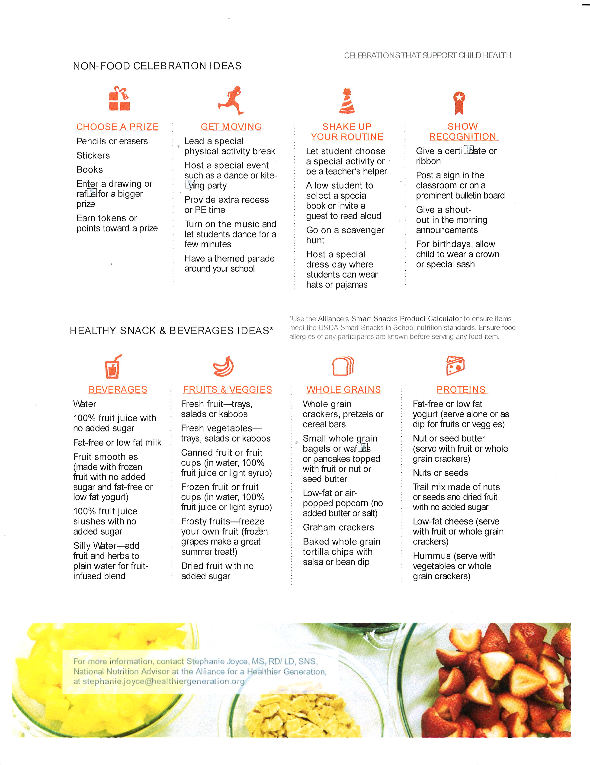

Smart Snacks
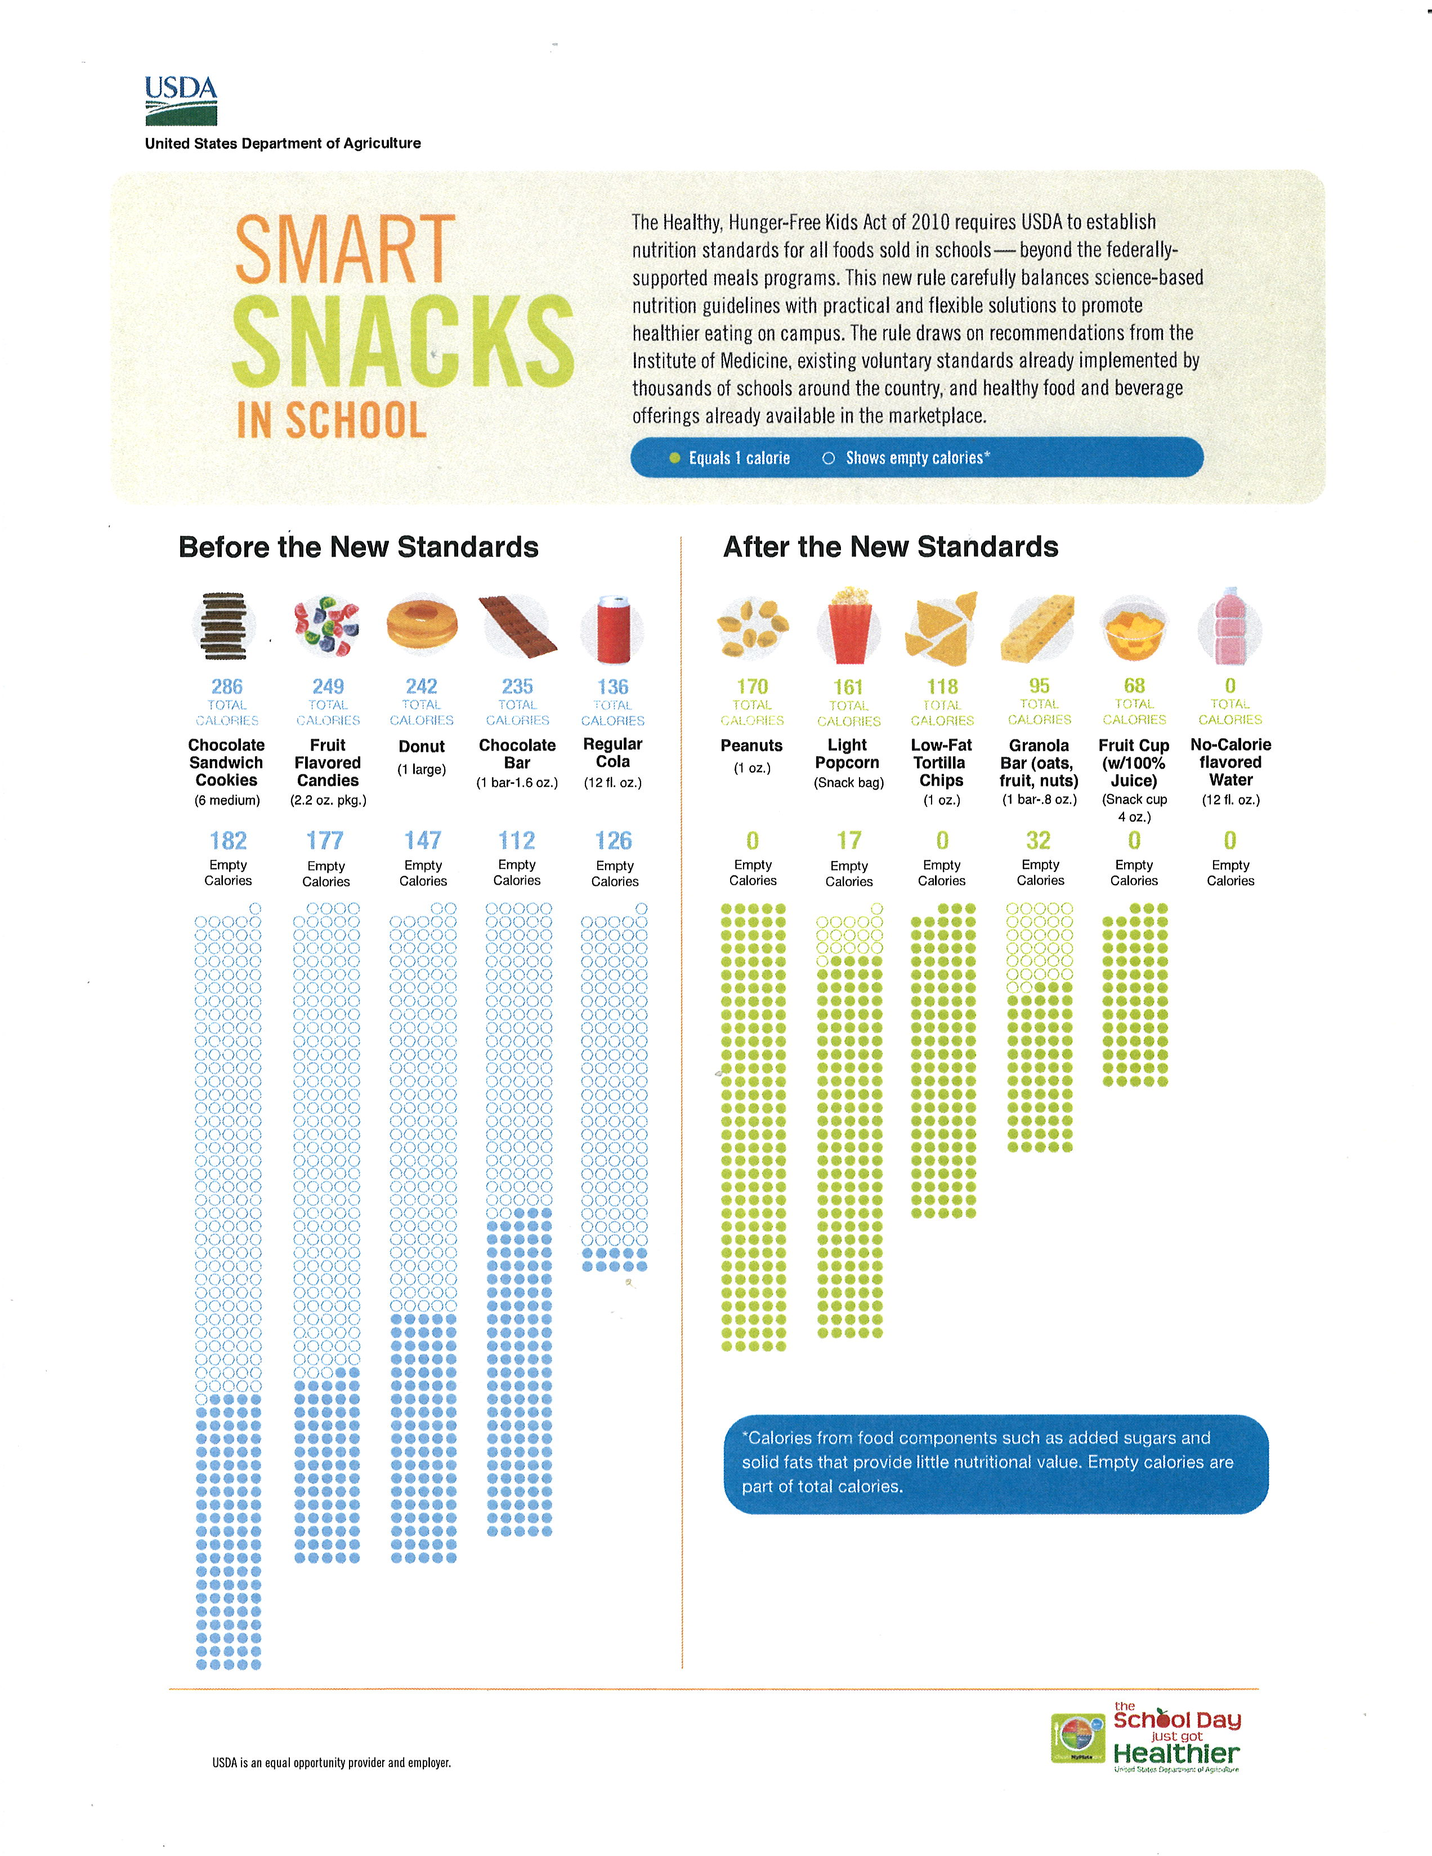
The Smart Snacks in School nutrition standards apply to any foods sold to students during the school day on the school campus, including foods sold as fundraisers.

Fundraisers and Smart Snacks: Foods Not Intended for Consumption at School
What can we sell for a fundraiser? If the item being sold is a nonfood item or a food item that meets the Smart Snacks standards, it can be sold anytime. State agencies can permit occasional exempt fundraisers, allowing the sale of foods that do not meet the standards. Organizations planning fundraisers should work with their school administration before initiating a fundraiser to ensure compliance with the Local Wellness Policy, Smart Snacks standards, and any other local policies that may be in place.
What if the foods do not meet the standards? Generally, foods that do not meet the standards cannot be sold to students on campus during the school day. Organizations planning fundraisers of foods that do not meet the standards must work with their school administration to determine if their fundraiser can be allowed as one of the school’s limited exempt fundraisers. It is important to remember that the standards do not apply during nonschool hours, on weekends, and at off-campus fundraising events, though local policies may still apply.
No more frozen pizza sales? No more cookie dough? No more Thin Mints®* cookies? Not necessarily! Many extracurricular programs, such as the school band, sports teams, and the school choir as well as youth-based community organizations such as the scouting programs rely on fundraisers to support their activities. There are ways that these groups can continue to raise money on campus under the standards, if allowed under local policies and approved by the school administration.
First, remember that all fundraising activities that take place outside of school are exempt from Smart Snack Standards. Just double-check your Local School Wellness Policy to see if other local school policies are in place!
Sale of frozen pizza, cookie dough and other items preordered and distributed in a precooked state or in bulk quantities (multiple servings in a package) for consumption at home is not required to meet the standards. For example, boxes of preordered Girl Scout cookies intended for consumption at home would not be subject to the standards. Students could take orders and deliver them during the school day for consumption outside of school.
Can we take fundraising orders at school? Yes. Orders may be taken at school as long as the foods being sold meet the Smart Snacks standards or are not intended to be consumed on campus during school hours and as long as students receive permission from the school.
Can we deliver the preordered fundraising items at school? Foods that have been purchased through a fundraiser may be delivered on the school campus during the school day if the foods being sold meet the standards or are not intended to be consumed on campus during school hours and as long as students receive permission from the school. However, we encourage *Mention of companies or commercial products does not imply recommendation or endorsement by the U.S. Department of Agriculture over others not mentioned or shown.
organizations to deliver the foods at a time when parents and caregivers are more likely to be present to collect the items, for example, during specific drop off or pickup times.
Can we sell individual food items that students can eat during the school day? If the foods being sold meet the standards, then you may sell them during the day. However, when the fundraiser includes the sale of food items that do not meet the standards, for example, a doughnut or a candy bar, the fundraiser must be considered an approved exempt fundraiser in accordance with the State agency. The fundraising organization, such as the school band, could then sell doughnuts or candy to students during the allocated exempt fundraising period.
Communication between youth-based organizations and school administration is critical when planning fundraising events on school campus during the school day.
Need more information? We offer a number of tools and resources to help school staff, parents, and students navigate fundraising tactics including the following:
• Memorandum: Smart Snacks Nutrition Standards and Exempt Fundraisers

http://www.fns.usda.gov/sites/default/files/SP36-2014os.pdf
• Issue Brief: Fundraisers

http://www.fns.usda.gov/sites/default/files/allfoods_fundraisers.pdf
• Healthy Fundraising (USDA Healthy Meals Resource System) http://healthymeals.nal.usda.gov/local-wellness-policy-resources/wellness-policy-elements/healthy-fundraising

Other policy guidance and resource materials on Smart Snacks may be found at the Food and Nutrition Service website at http://www.fns.usda.gov/healthierschoolday/tools-schools-smart-snacks.
USDA is an equal opportunity provider and employer

Addendum

Monitoring Implementation of Goals:

Goal | Measures of Implementation and Success | Status 2022
- The school will continue to provide breakfast and lunch to all students at no charge. | Breakfast, second chance breakfast and lunch are provided | CNIPS records are available at the state level, and by inquiring at the District office.  Menus are posted on the school website and on file at the school.
- Students receive quality nutrition education that helps them develop lifelong healthy eating behaviors; | The School shall maintain a copy of the syllabi that include nutrition education (i.e. P.E. and Food or Culinary classes.) These teachers have been asked to explain better in the syllabi what they cover. | These syllabi are on file at the school in the main office and in the library.
- Students have opportunities to be physically active before, during and after school; | Weight Room will be made available before or after school hours. Activity will be available during lunch. | The weight room is open at certain times after school. Pickle Ball is available during lunch. Skiing is offered during the winter months once a week.
- Schools engage in nutrition and physical activity promotion and other activities that promote student wellness; | Maintain records about promoting health and nutrition. | The Wellness Policy is posted around school and on the website. Additional posters are displayed in the cafeteria area. Nutrition fliers and health fliers are sent home to parents and families.
- School staff are encouraged and supported to practice healthy nutrition and physical activity behaviors in and out of school; | Maintain records of physical activities in which staff participates. | I teacher coordinates pickleball at lunch. One teacher opens the weight room after school when available. 3 teachers act as team sport coaches.
- The community is engaged in supporting the work of the District in creating continuity between school and other settings for students and staff to practice lifelong healthy habits; | Maintain records of nutritional information posted on line or sent to parents and families.  Continue to make team sports a spectator event. | The work has been ongoing. A file system separate from other parent notification files will be maintained. All team sports are open to spectators.
- The District establishes and maintains an infrastructure for management, oversight, implementation, communication about and monitoring of the policy and its established goals and objectives. | Maintain record re Agendas and Minutes of Site Council regarding the Wellness Plan. | The work has been ongoing. A file system separate from other site council files is maintained.
- The District will continue, and expand were possible, programs that provide emotional support and mental health, | Number of SEL programs and events  Availability of a therapist and nurse. | The District contracts with a behavior therapist and school nurse who each can see students and also refer students to individual specialists.  The school had 3 SEL events this year (paradigm Shift twice, and Dr. Manny Scott.

Resources Bradley, B, Green, AC. Do Health and Education Agencies in the United States Share Responsibility for Academic Achievement and Health? A Review of 25 years of Evidence About the Relationship of Adolescents’ Academic Achievement and Health Behaviors, Journal of Adolescent Health. 2013; 52(5):523–532.
Meyers AF, Sampson AE, Weitzman M, Rogers BL, Kayne H. School breakfast program and school performance. American Journal of Diseases of Children. 1989;143(10):1234–1239.
Murphy JM. Breakfast and learning: an updated review. Current Nutrition & Food Science. 2007; 3:3–36.
Murphy JM, Pagano ME, Nachmani J, Sperling P, Kane S, Kleinman RE. The relationship of school breakfast to psychosocial and academic functioning: Cross-sectional and longitudinal observations in an inner-city school sample. Archives of Pediatrics and Adolescent Medicine. 1998;152(9):899–907.
Pollitt E, Mathews R. Breakfast and cognition: an integrative summary. American Journal of Clinical Nutrition. 1998; 67(4), 804S–813S.
Rampersaud GC, Pereira MA, Girard BL, Adams J, Metzl JD. Breakfast habits, nutritional status, body weight, and academic performance in children and adolescents. Journal of the American Dietetic Association. 2005;105(5):743–760, quiz 761–762.
Taras, H. Nutrition and student performance at school. Journal of School Health. 2005;75(6):199–213.
MacLellan D, Taylor J, Wood K. Food intake and academic performance among adolescents. Canadian Journal of Dietetic Practice and Research. 2008;69(3):141–144.
Neumark-Sztainer D, Story M, Dixon LB, Resnick MD, Blum RW. Correlates of inadequate consumption of dairy products among adolescents. Journal of Nutrition Education. 1997;29(1):12–20.
Neumark-Sztainer D, Story M, Resnick MD, Blum RW. Correlates of inadequate fruit and vegetable consumption among adolescents. Preventive Medicine. 1996;25(5):497–505.
Centers for Disease Control and Prevention. The association between school-based physical activity, including physical education, and academic performance. Atlanta, GA: US Department of Health and Human Services, 2010.
Singh A, Uijtdewilligne L, Twisk J, van Mechelen W, Chinapaw M. Physical activity and performance at school: A systematic review of the literature including a methodological quality assessment. Arch Pediatr Adolesc Med, 2012; 166(1):49-55.
Haapala E, Poikkeus A-M, Kukkonen-Harjula K, Tompuri T, Lintu N, Väisto J, Leppänen P, Laaksonen D, Lindi V, Lakka T. Association of physical activity and sedentary behavior with academic skills – A follow-up study among primary school children. PLoS ONE, 2014; 9(9): e107031.
Hillman C, Pontifex M, Castelli D, Khan N, Raine L, Scudder M, Drollette E, Moore R, Wu C-T, Kamijo K. Effects of the FITKids randomized control trial on executive control and brain function. Pediatrics 2014; 134(4): e1063-1071. 15 Change Lab Solutions. (2014). District Policy Restricting the Advertising of Food and Beverages Not Permitted to be Sold on School Grounds. Retrieved from http://changelabsolutions.org/publications/district-policy-school-food-ads Referenced Resources U.S. Department of Agriculture (USDA) Food and Nutrition Service Summary of the Final Rule (PDF) handout Centers for Disease Control and Prevention Whole School, Whole Community, Whole Child model web page USDA School Meal Program Nutrition Standards web page California Department of Education (CDE) Federal & State Competitive Food Rule Update (SNP-09-2019) management bulletin CDE Competitive Food and Beverage web page Torrance Unified School District Creating a Culture of Wellness (PDF) handout Rudd Center Wellness School Assessment Tool (WellSAT: 3.0) web page Centers for Disease Control and Prevention School Health Index web page California LSWP Collaborative Triennial Assessment Guidance (DOCX) handout California LSWP Collaborative Does Your LSWP Measure Up? (PDF) checklist USDA Nondiscrimination Statement web page

